1) Enable cloudtrail monitoring and store the events in s3 and cloudwatch log events.

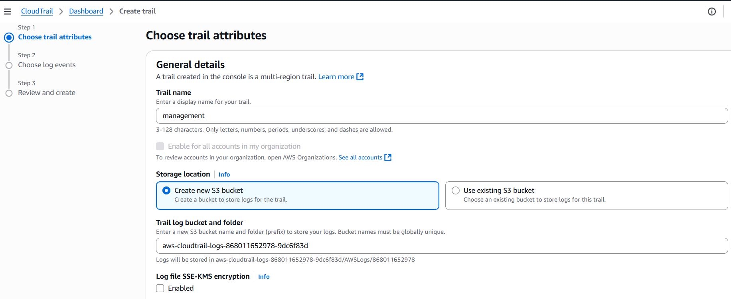

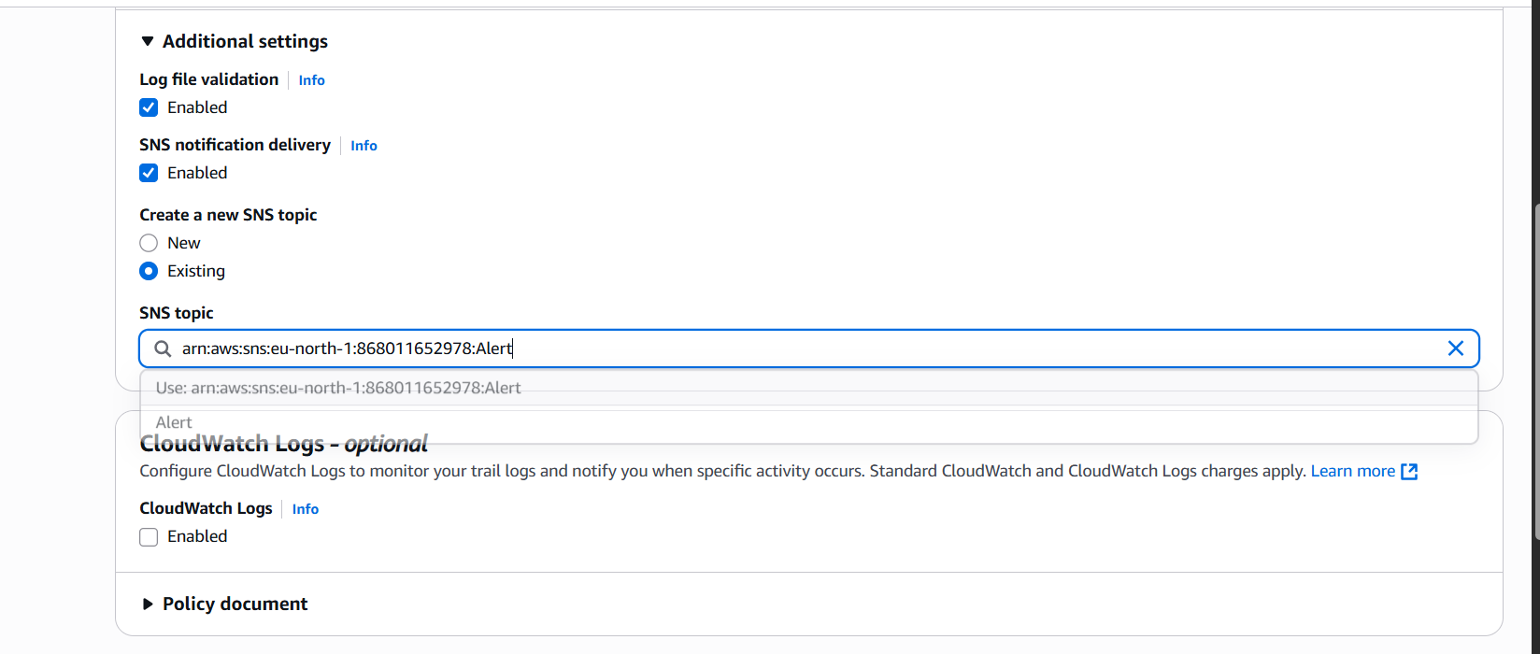

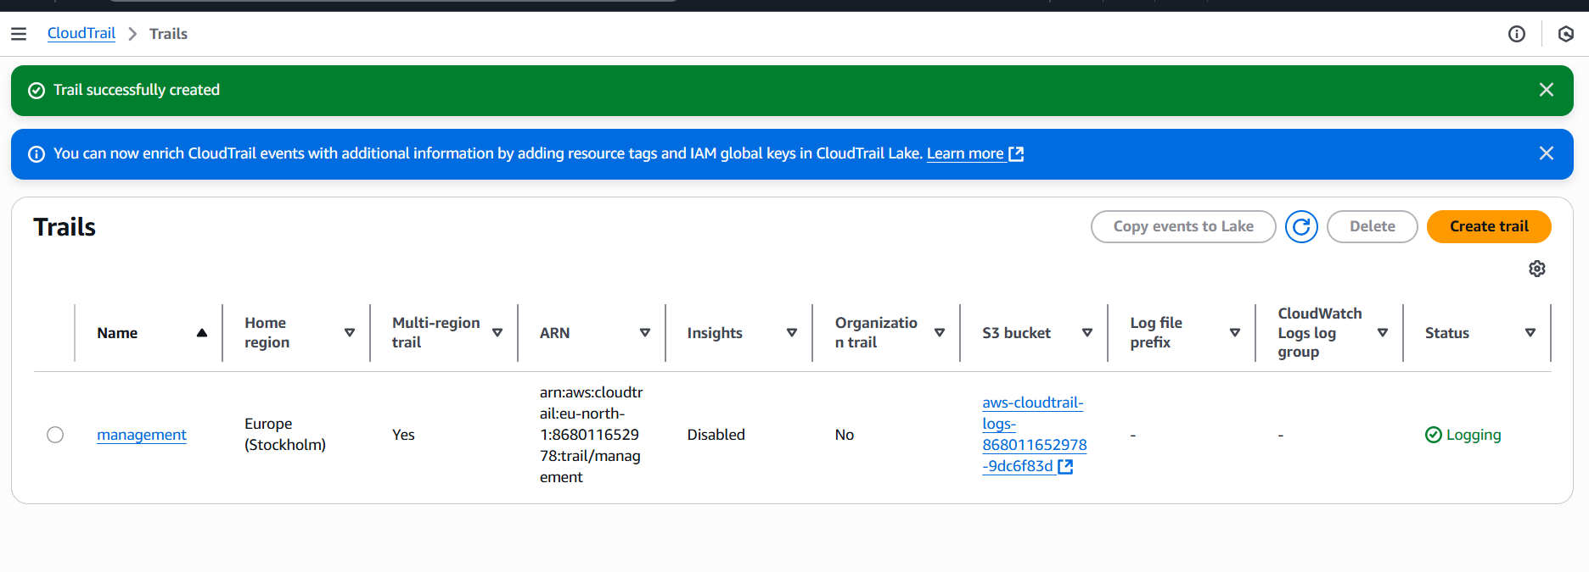

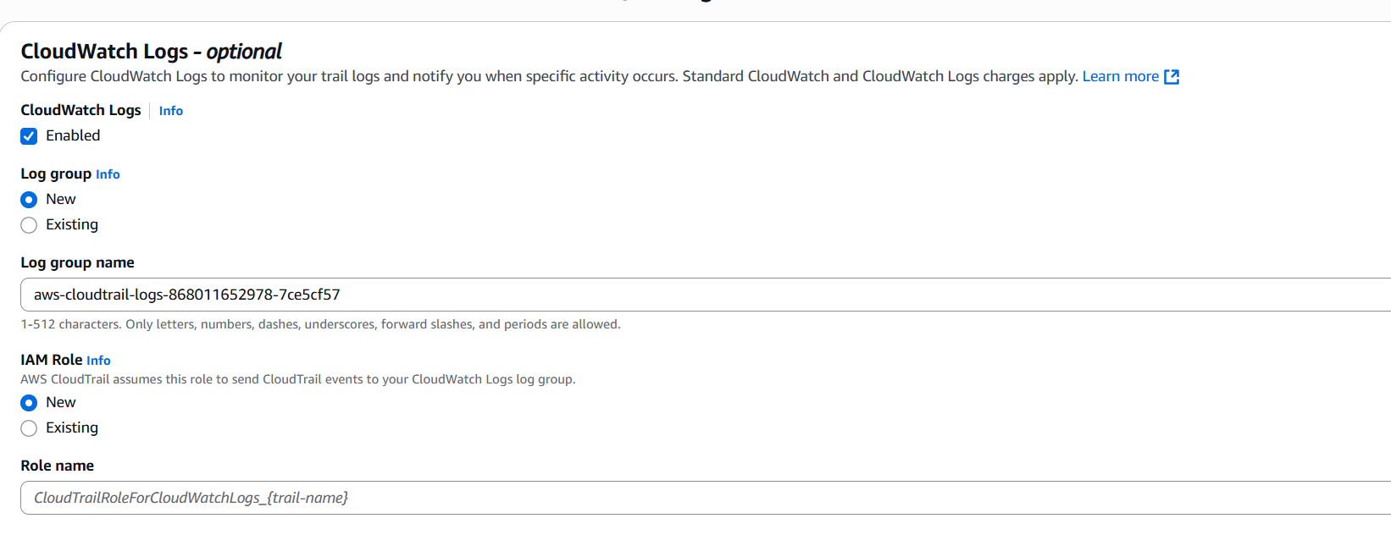

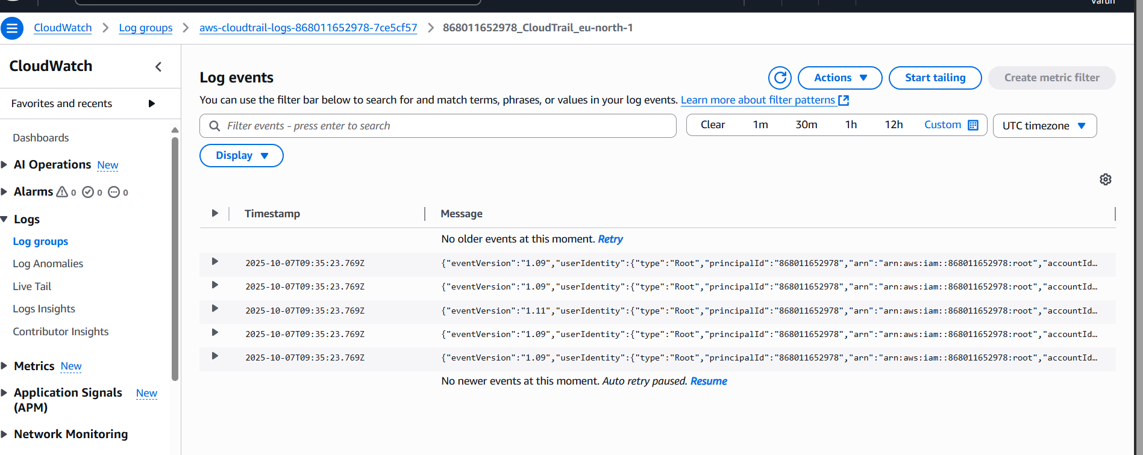

* Go to cloud trail-create
* Create trail work flow
* Give the name to the trail.
* Enable logs and create a new role for SNS alerts
* Then create trail logs.
* Now go to cloud watch->log groups. We will find the log created.
* Log streams to check the logs.

2) Enable SNS for cloudtrial to send alert on email.

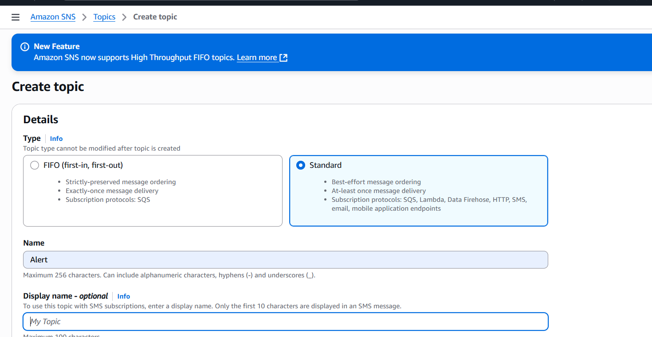

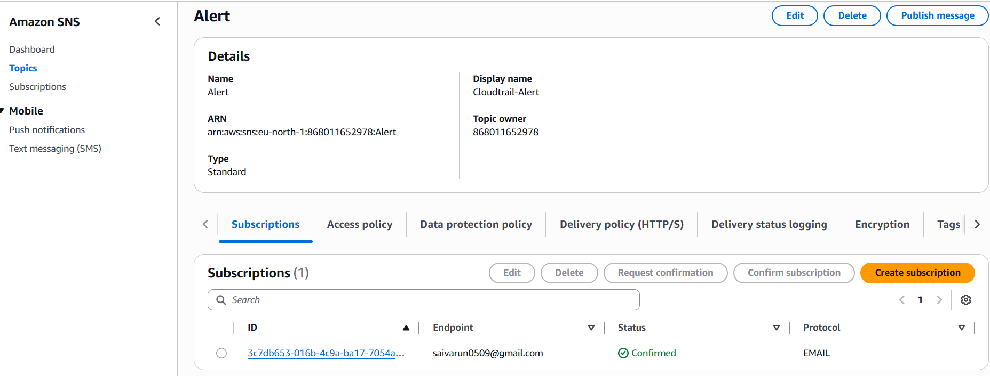

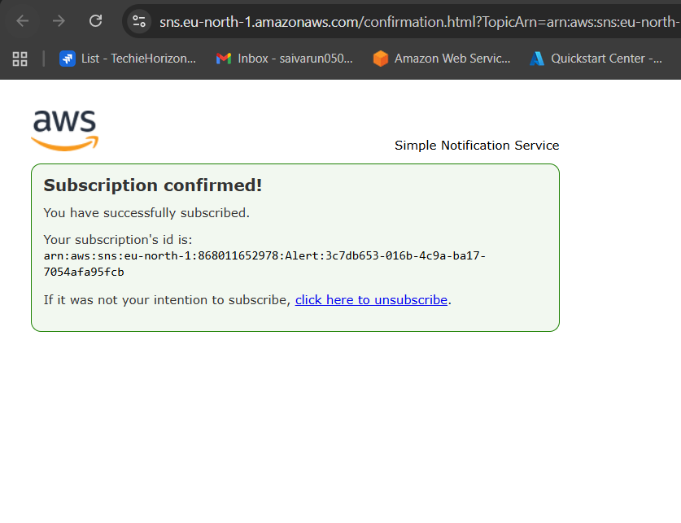

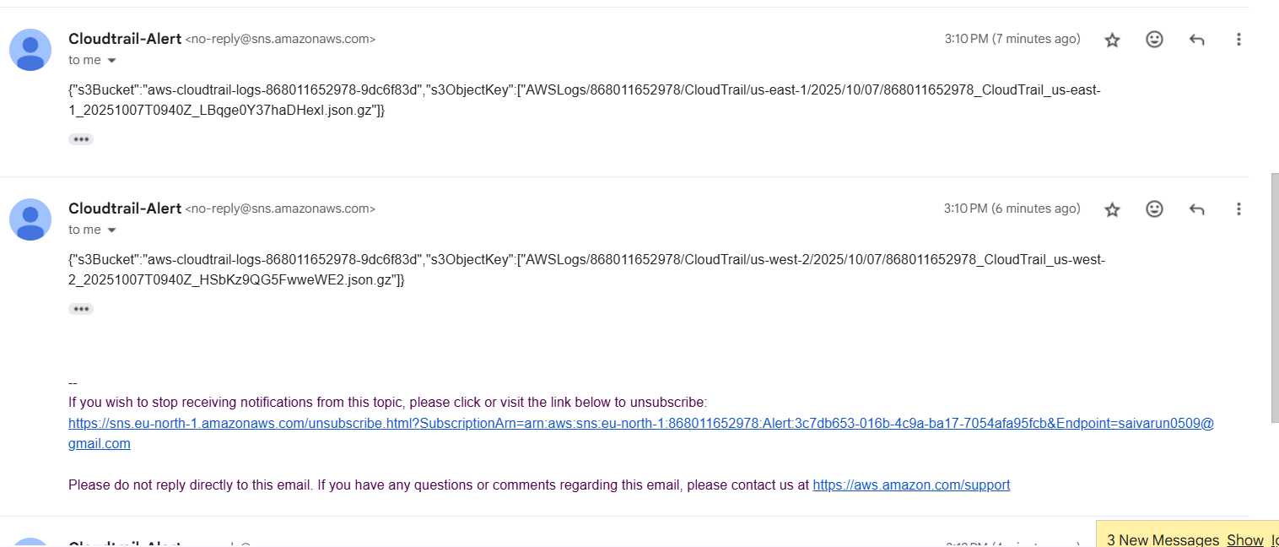

•Configure the sns for the cloud trail to send the alert to your phone or   
email  
•Go to sns (simple notification service)  
•Create subscription◊topic name◊provide your email address and   
create the topic  
•Confirm the the subscription fro your email then the sns is created   
successfully.

3) Configure cloud watch monitoring and record the cpu utilization and other metrics of ec2.

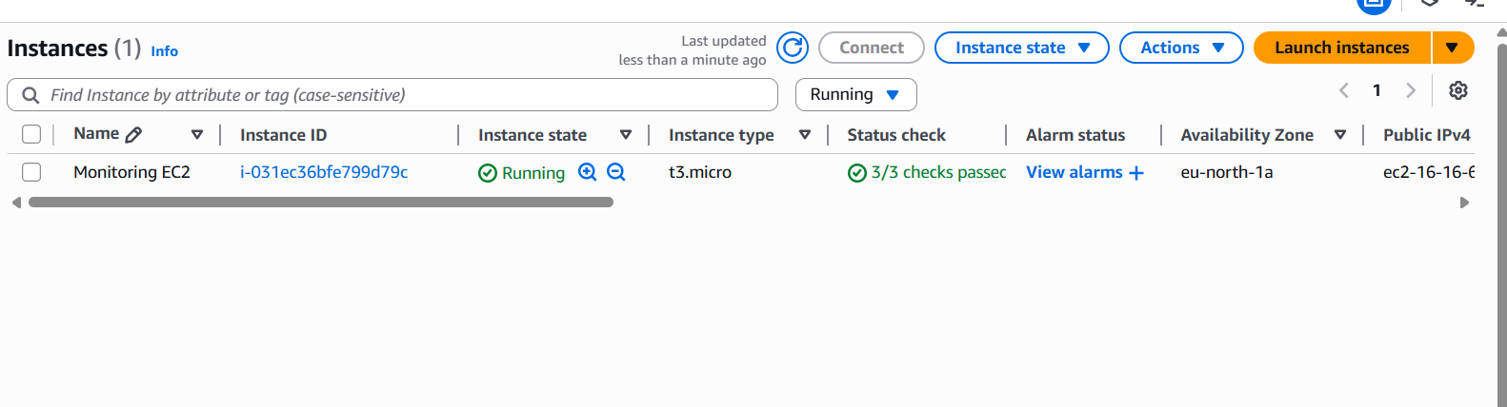

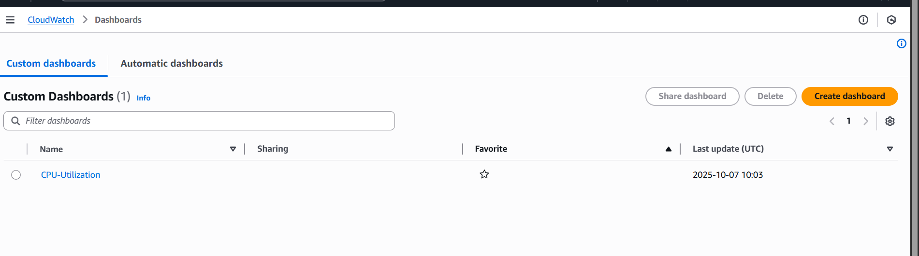

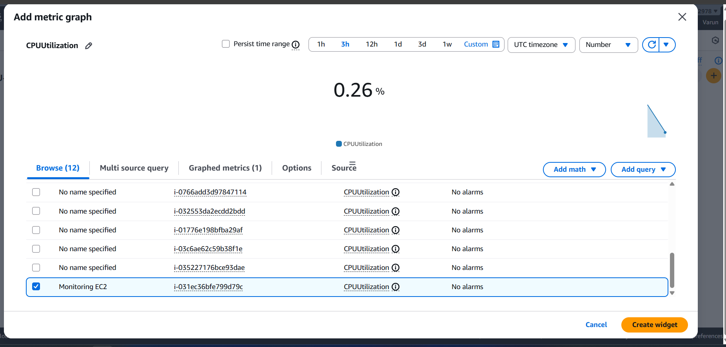

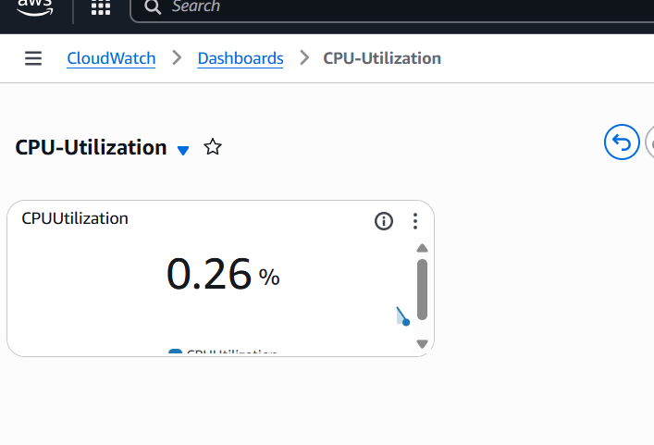

•Launch one ec2 instance  
•Go to cloud watch◊dashboard◊create daash board  
•Go to the dash board created ->add metric graphs -> select   
ec2 ->select the graph you want to monitor ->create widget type   
graph sleect and create the widget you can monitor cpu utiliation

4) Create one alarm to send alert to email if the cpu utilization is more than 70 percent.

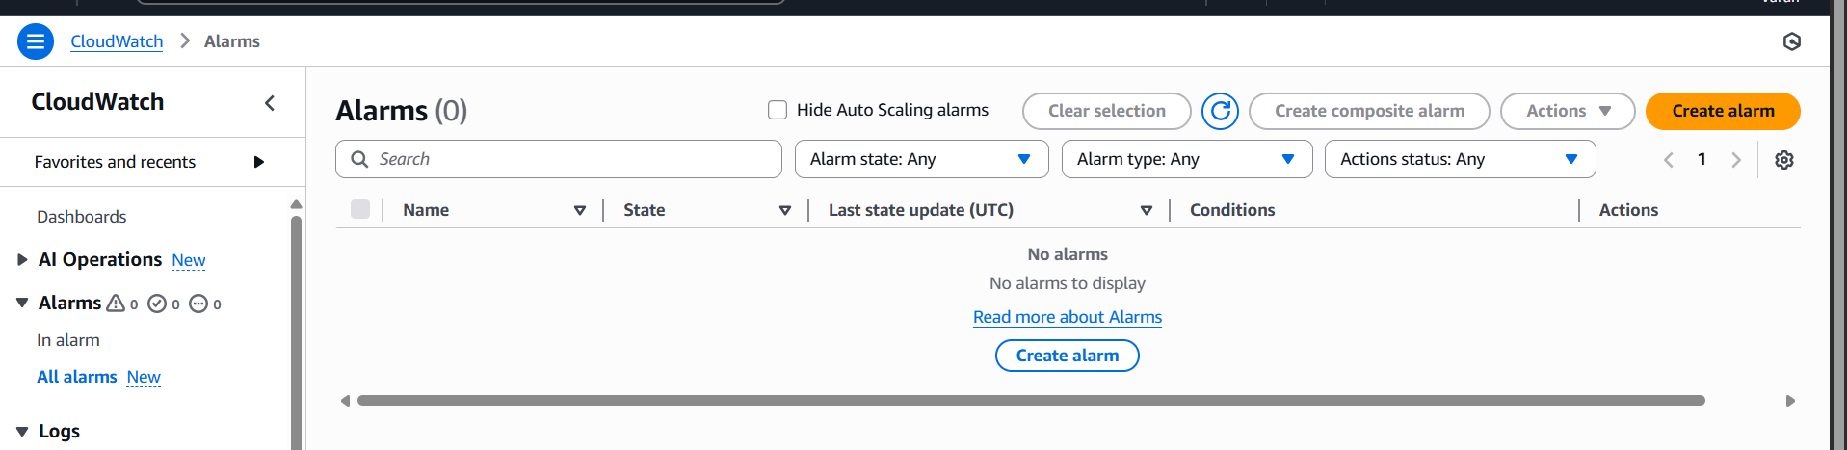

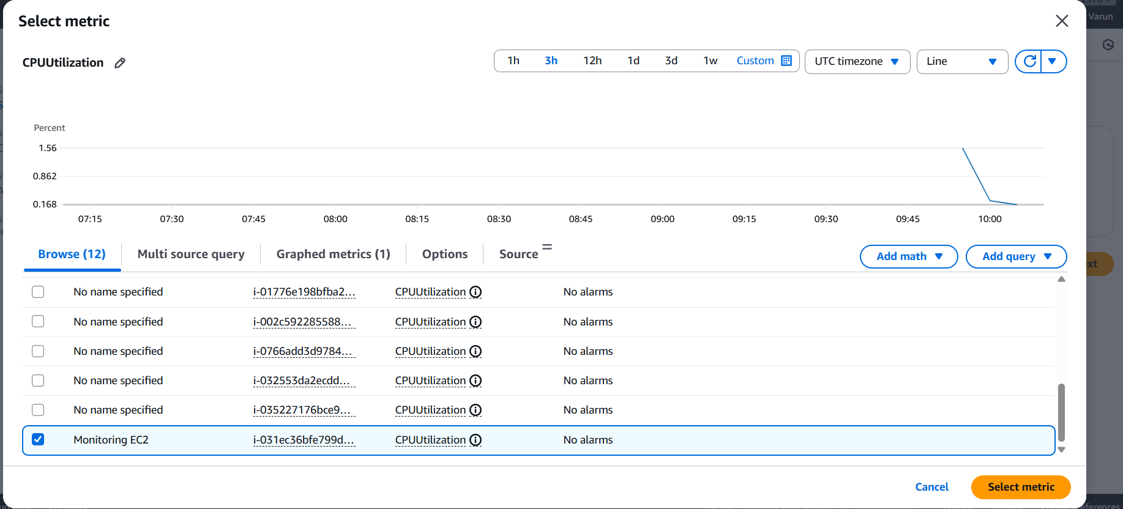

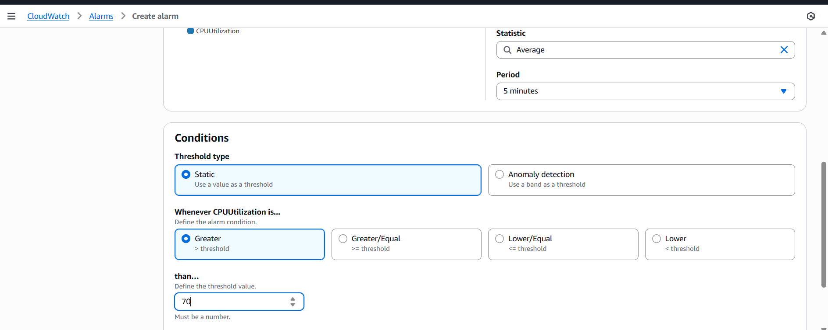

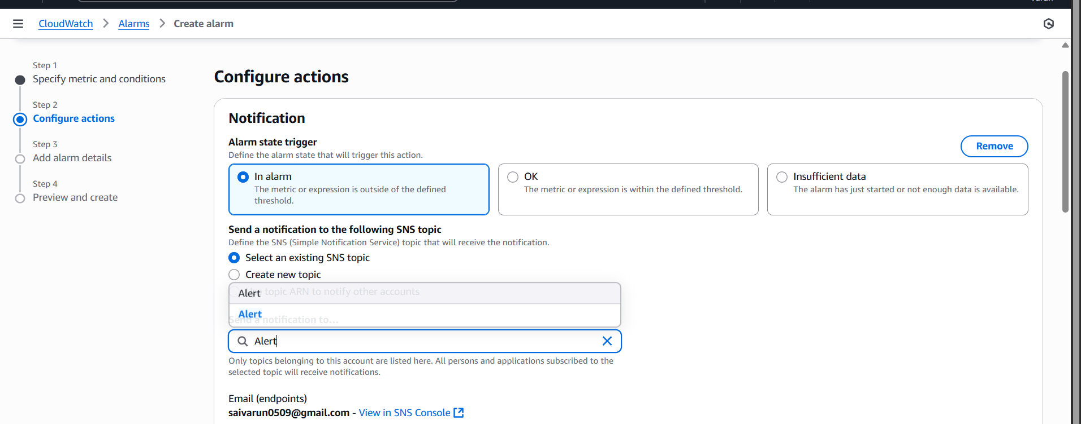

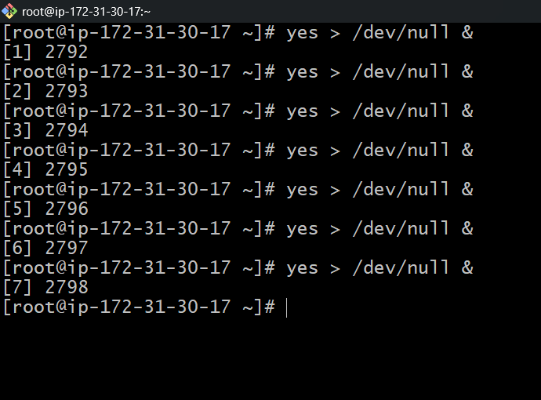

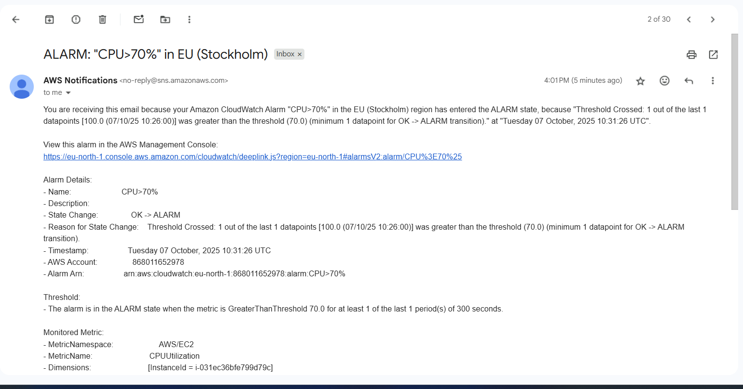

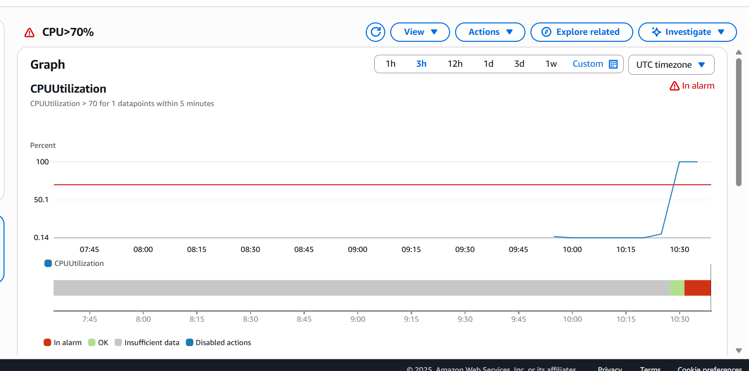

•Go to cloud watch ◊create alarm◊  
•Select the metric◊or search with instance id ->select cpu   
utilization ->give the parameter greater than 70 ->select the sns ->create alarm  
•Now check the alarm and email will be sent to your mail id for the   
usage is more than the 70%

5) Create Dashboard and monitor tomcat service whether it is running or not and send the alert.

[Same as Task-6 just need to add tomcat script.]

#!/bin/bash#set -x  
INSTANCE_ID=$(/opt/aws/bin/ec2-metadata -i | cut -d " " -f2)checkTomcatStatus(){  
        counter=0  
        ps x | grep /opt/apache-tomcat-9.0.65/ | grep -v grep |    #Need to change tomcat version  
        while read -r LINE  
        do  
                read PROCESS_ID <<< $LINE  
                counter=$((counter+1))  
                echo $counter  
        done  
}i=$(checkTomcatStatus)  
#echo $iif [ "$i" == "" ]  
then  
        aws --region ap-south-1 cloudwatch put-metric-data --metric-name tomcat --value 0 --namespace tomcat --dimensions InstanceId=$INSTANCE_ID  
else  
        aws --region ap-south-1 cloudwatch put-metric-data --metric-name tomcat --value 1 --namespace tomcat --dimensions InstanceId=$INSTANCE_ID  
fi

# Need to change the region

6) Create Dashboard and monitor nginx service to send the alert if nginx is not running.

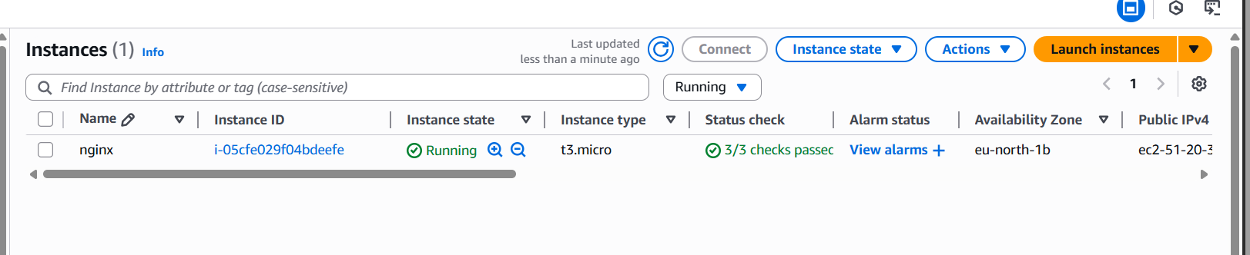

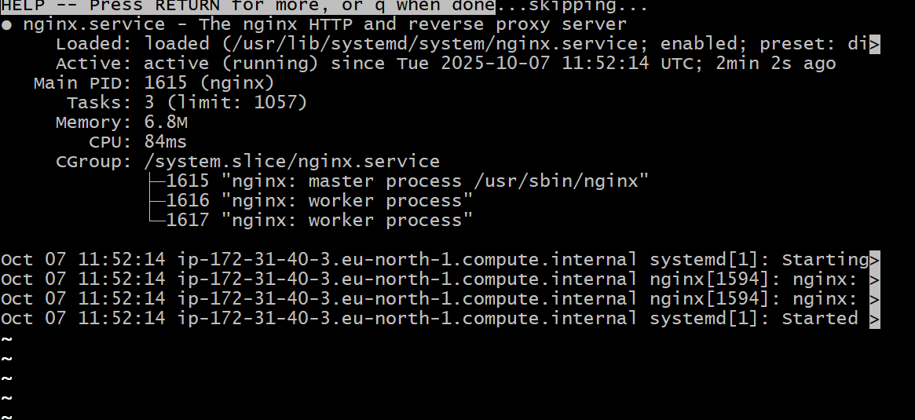

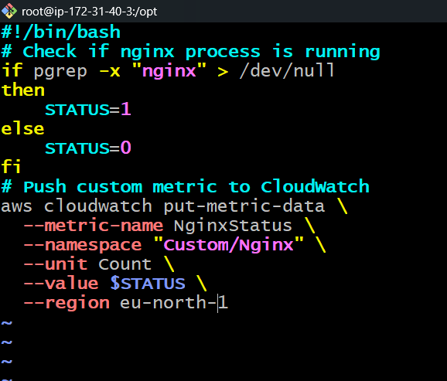

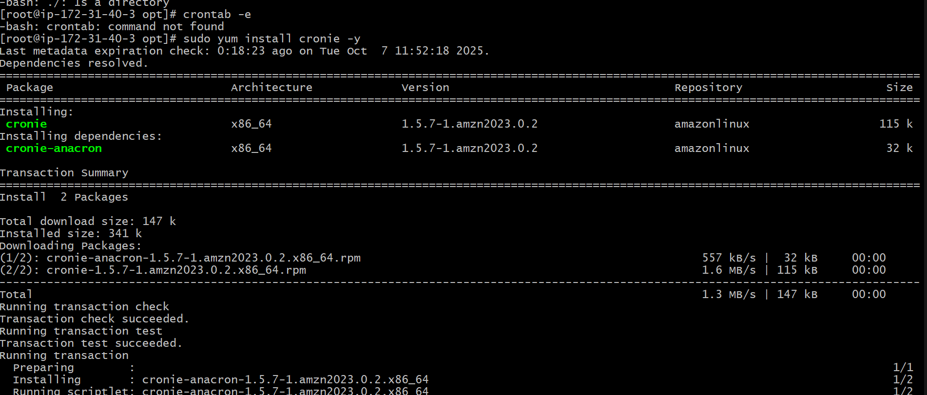



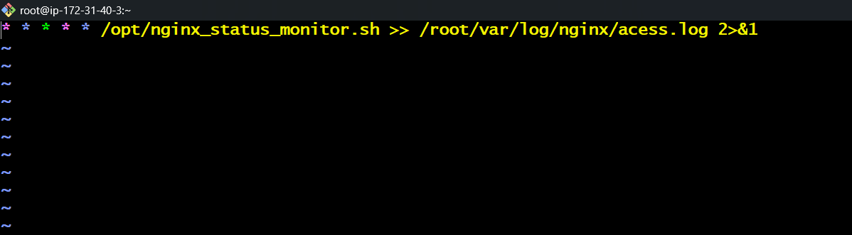

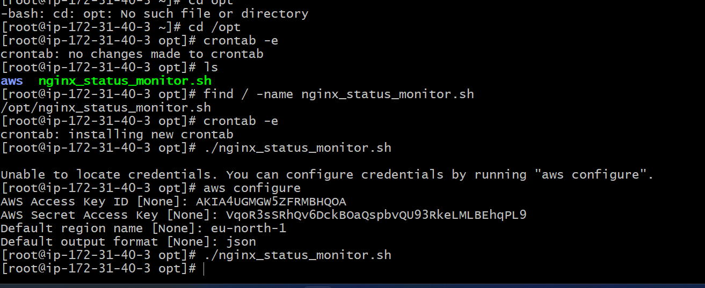

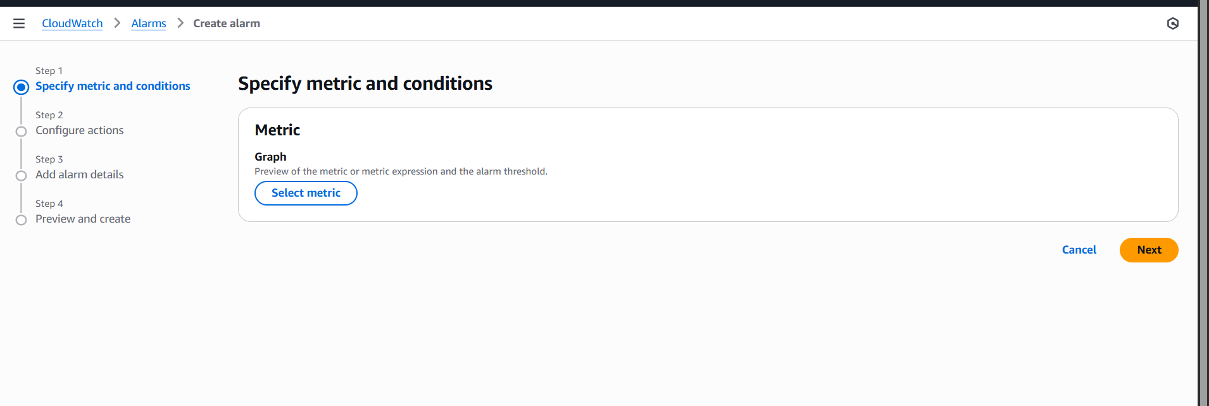

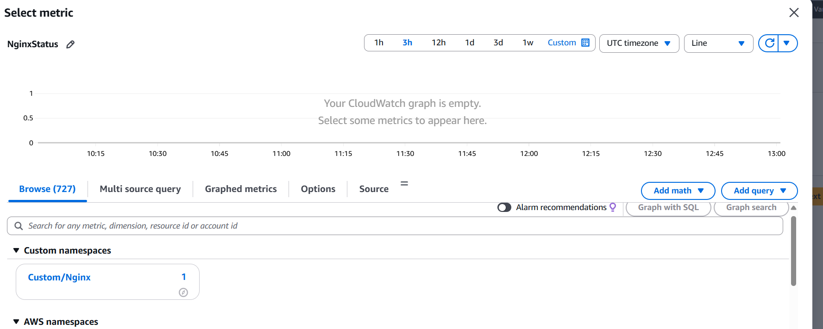

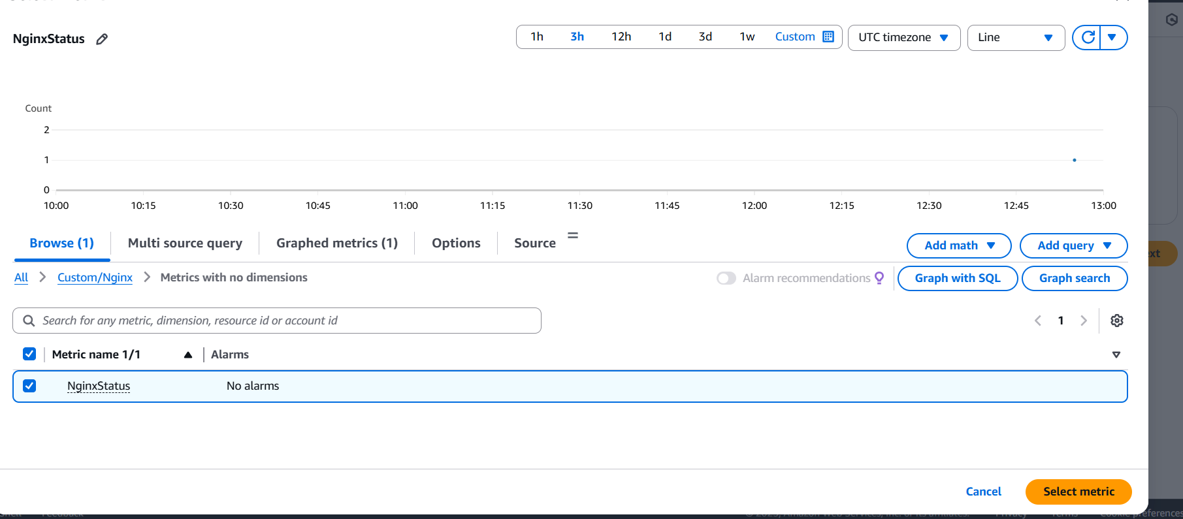

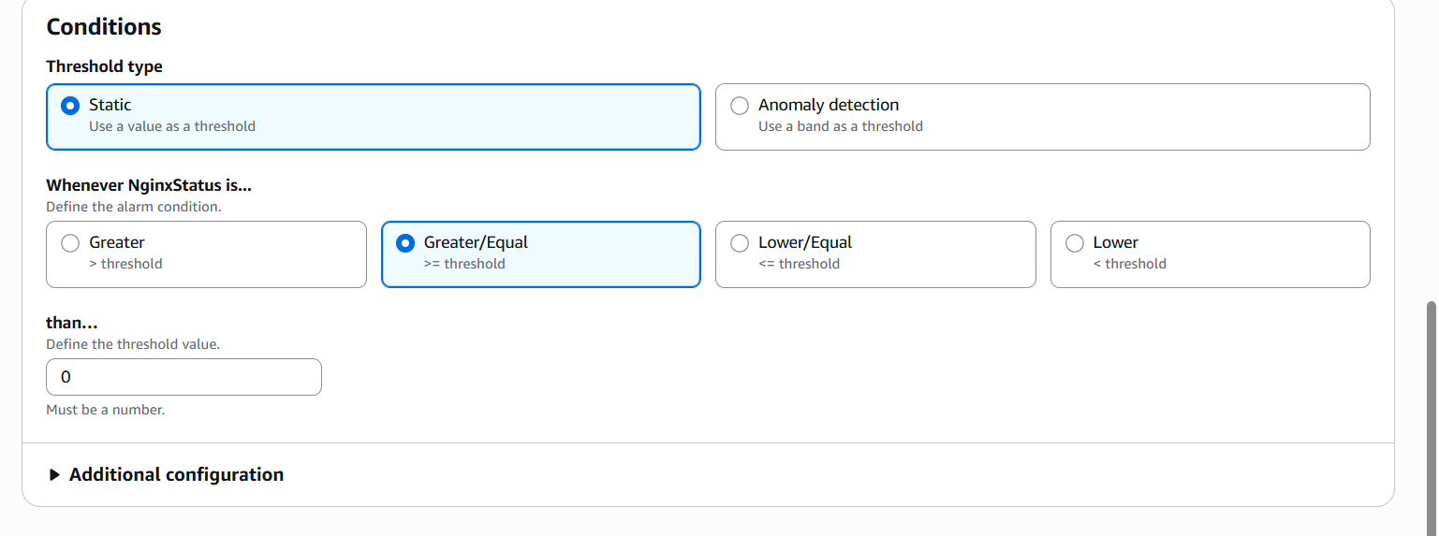

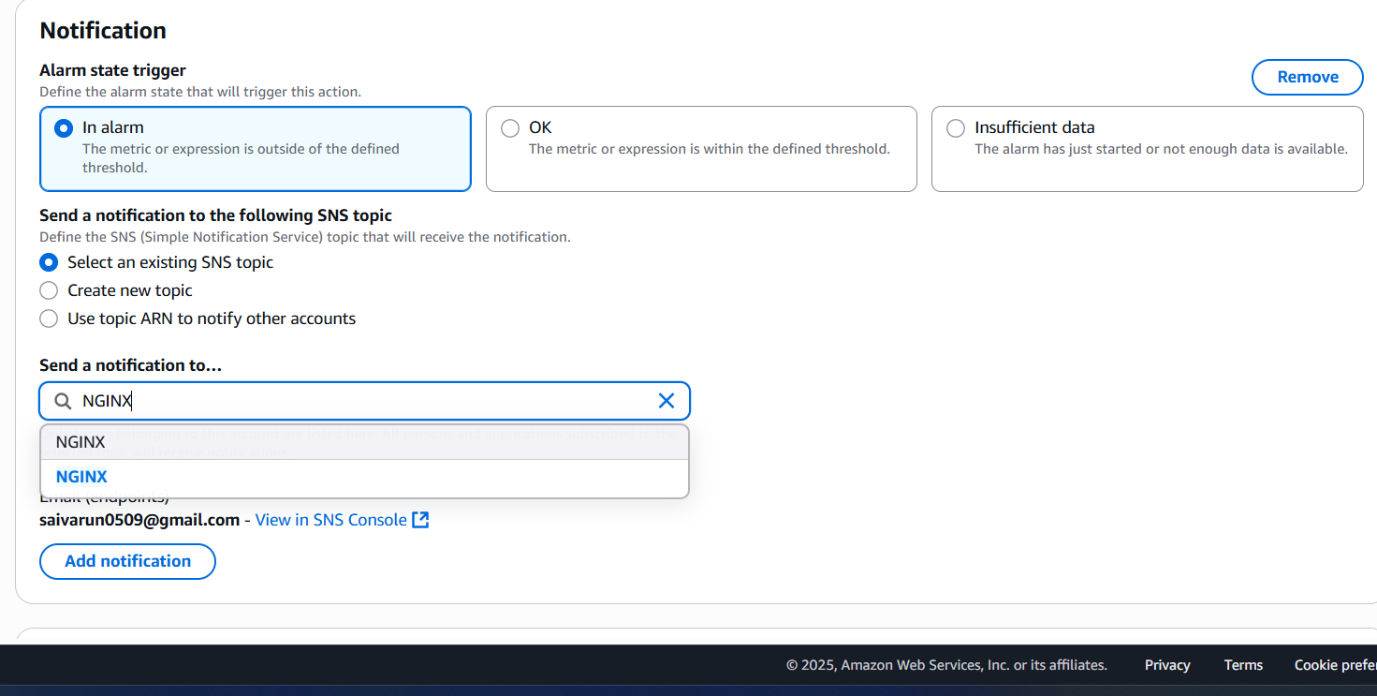

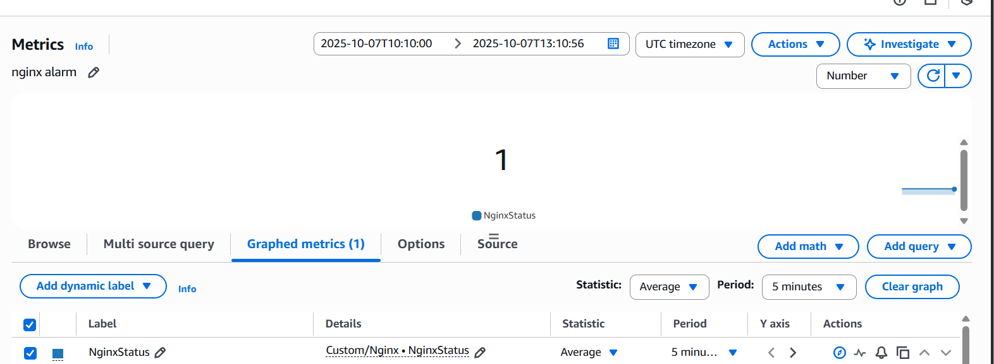

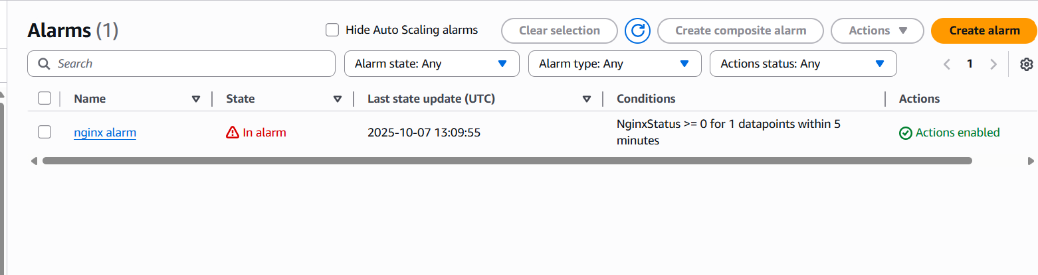

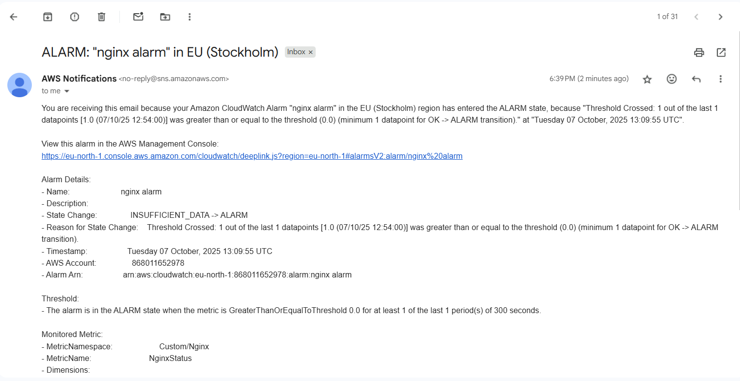

•Install nginx and start the nginx  
•Write a script to check and monitor the nginx service and push   
metrics to the cloud watch

•create dash board find nginx select you can see the nginx is being   
monitored  
•create cronjob for the script  
•script

#!/bin/bash# Check if nginx process is running  
if pgrep -x "nginx" > /dev/null  
then  
    STATUS=1  
else  
    STATUS=0  
fi# Push custom metric to CloudWatch  
aws cloudwatch put-metric-data \  
  --metric-name NginxStatus \  
  --namespace "Custom/Nginx" \  
  --unit Count \  
  --value $STATUS \  
  --region us-east-1

•go to the alarm in the cloud watch create alarm ->select the   
metrics ->select the value ◊create alarm  
•then it will send the alert that in alarm if its zero